**Problem 4 : JavaScript General Purpose Exercise**

**AIM:**

Develop and demonstrate a HTML file that includes java script for the following problems

1. Produce n Fibonacci numbers

(ii) Create a function to Reverse a string

**PROGRAM CODE:**

|  |  |
| --- | --- |
| fibrev.html | <html>  <body>  <b>Find Fibonacci series</b></br>  <input type="number" id="fib">  <input type="submit" value="Fibo" onclick=fun()>  </br>  </br>  <b> String Reverse </b></br>  <input type="text" id="re">  <input type="submit" value="Reverse" onclick="rev()">  <br>  <h4>Output:</h4>  <p id="dis"></p>  <script type="text/javascript">  function fun() {  var a = 0;  var b = 1  var c;  var d = []  var n = document.getElementById("fib").value;  for (var i = 2; i < n; i++) {  c = a + b;  a = b;  b = c;  d[i] = c  }  d[0] = 0;  d[1] = 1;  document.getElementById("dis").innerHTML = d;  }  function rev() {  var ne = "";  var x = document.getElementById("re").value;  var n = x.length;  for (var i = n - 1; i >= 0; i--) {  var ne = ne + x[i]  }  document.getElementById("dis").innerHTML = ne  }  </script>  </body>  </html> |

**RESULT**

These are the output display of pages that are specified in the aim of the program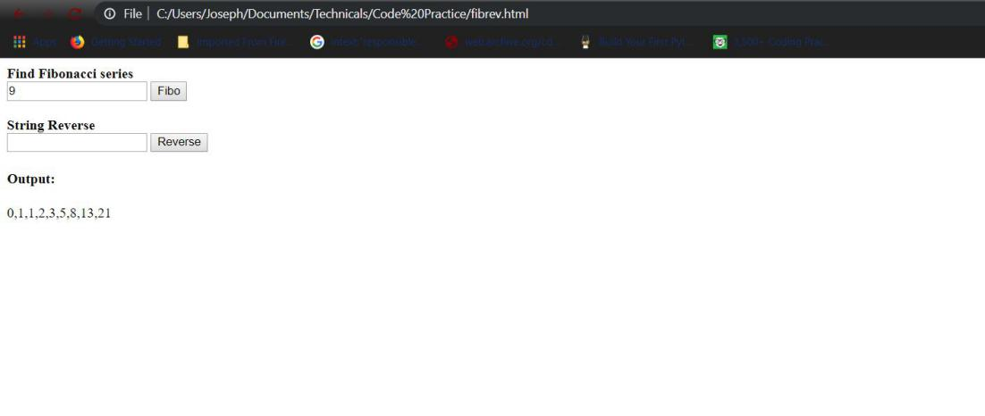

Figure 1: Webpage shows fibonacci series of first 9 numbers

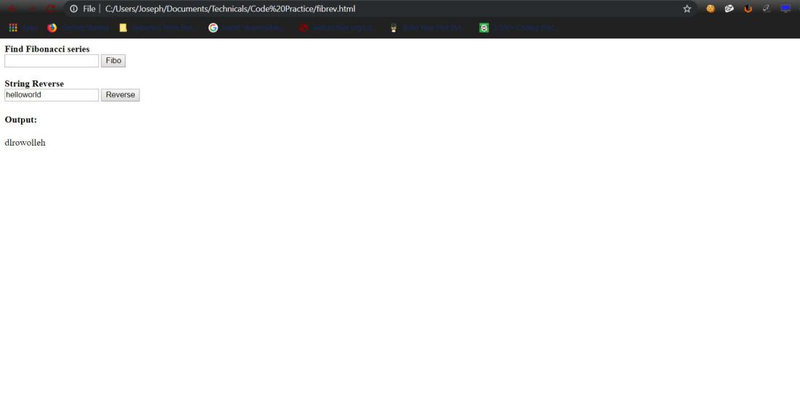

Figure 2: Webpage shows string reverse of “helloworld”